Assignment 1 - Git & GitHub Fundamentals
- Full Name: Malak Baddi
- Student ID: 158934
- Course Code & Section: CSC 3324 03
- GitHub Username:m4lak-b

1. Repository Setup

I initialized a Git repository inside the STARTER folder using git init. I created a .gitignore file to ignore local.env and regular .log files while keeping important.log visible to Git. I also created a README.md containing my name, GitHub username, project description, technologies, a code block, a link, and the provided project image.

2. README & Commit History
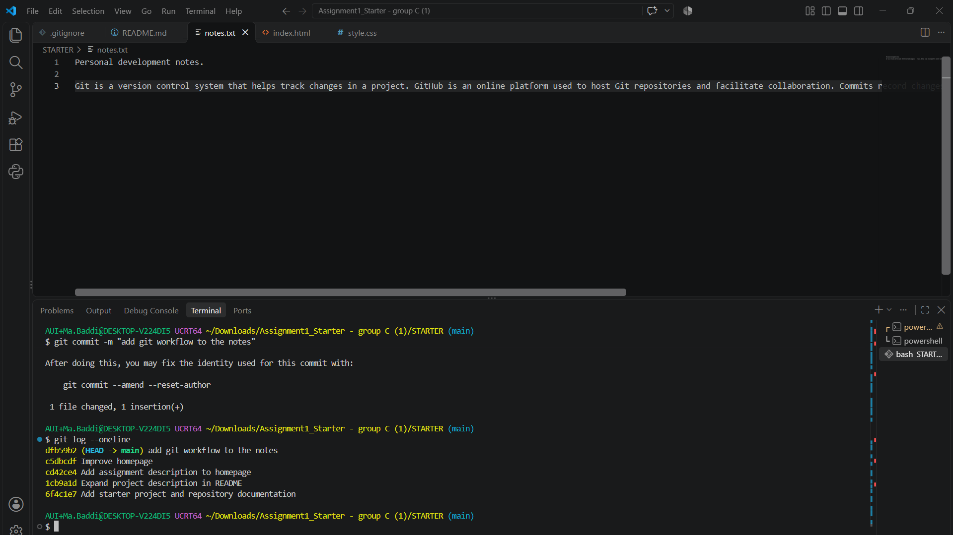

I created a README with the required project information, technologies, code example, link, and project image. I organized my work into meaningful commits covering repository setup, documentation, the homepage, styling, and project notes. I used git log --oneline to inspect the commit history.

3. Selective Staging

I modified notes.txt and index.html at the same time. I staged only notes.txt using git add notes.txt and checked git status to confirm that index.html remained unstaged. I then committed the staged file separately, demonstrating how Git allows selected changes to be included in a commit without automatically committing every modified file.

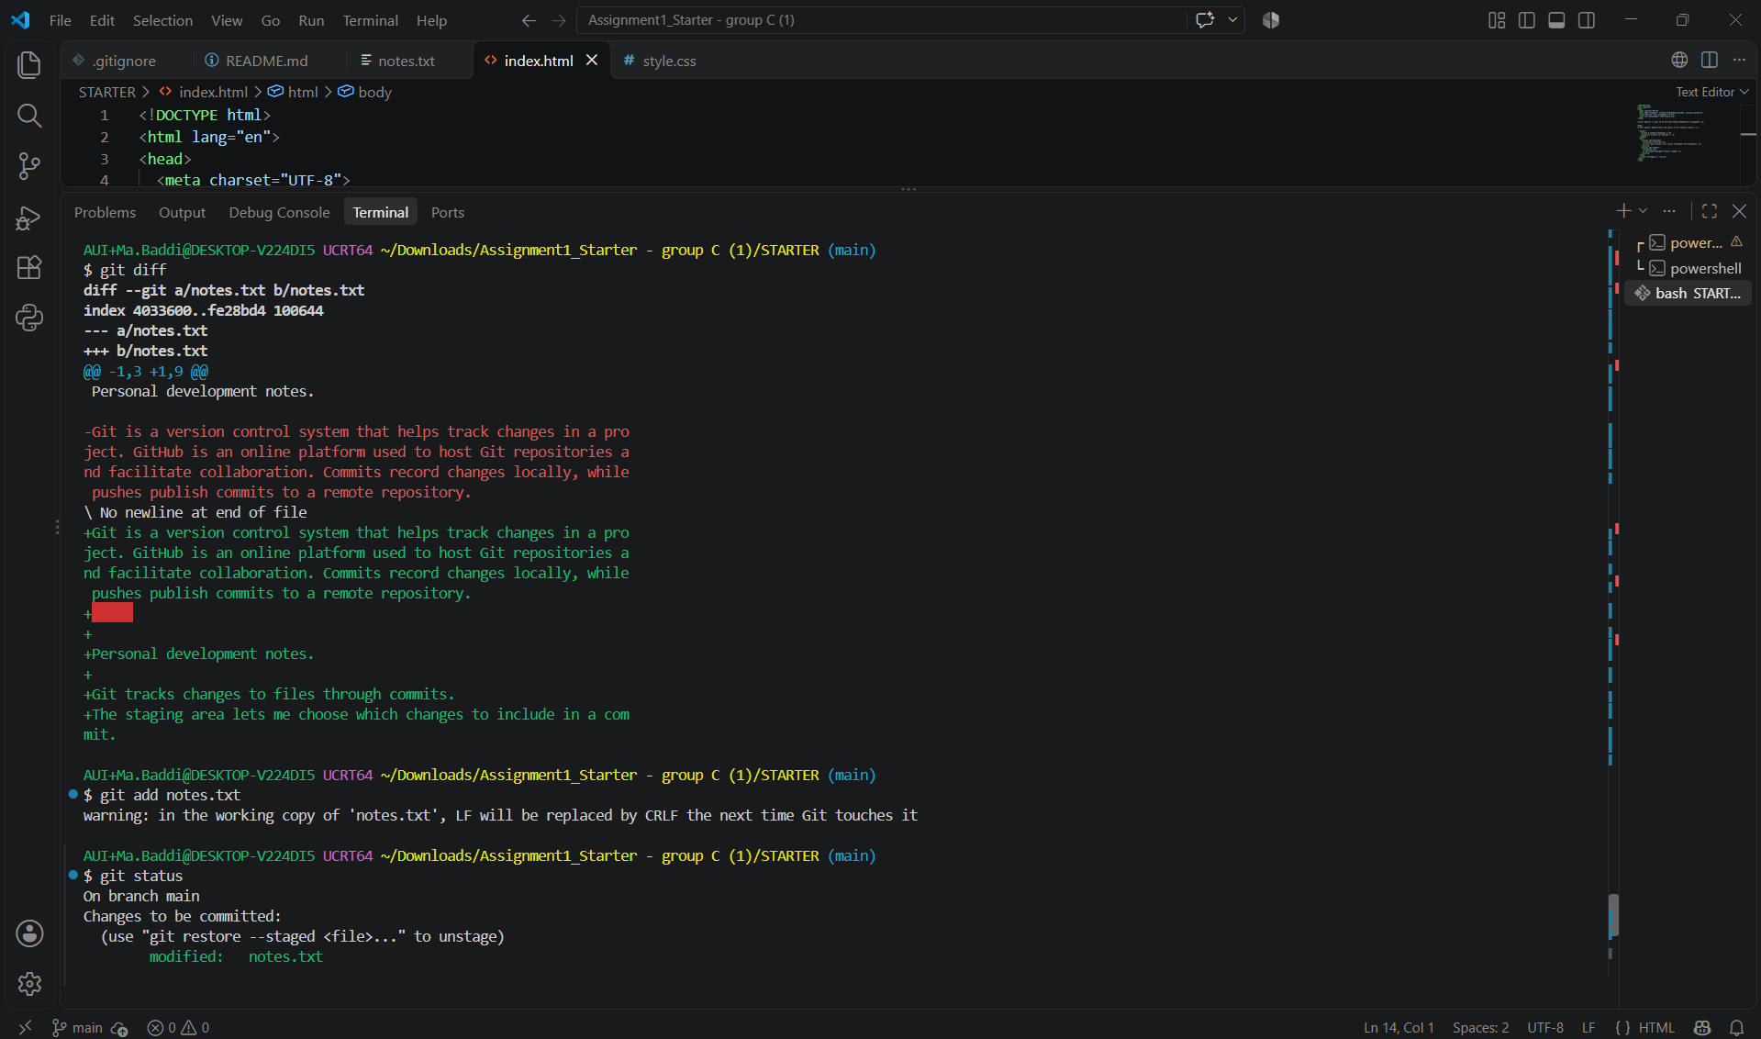

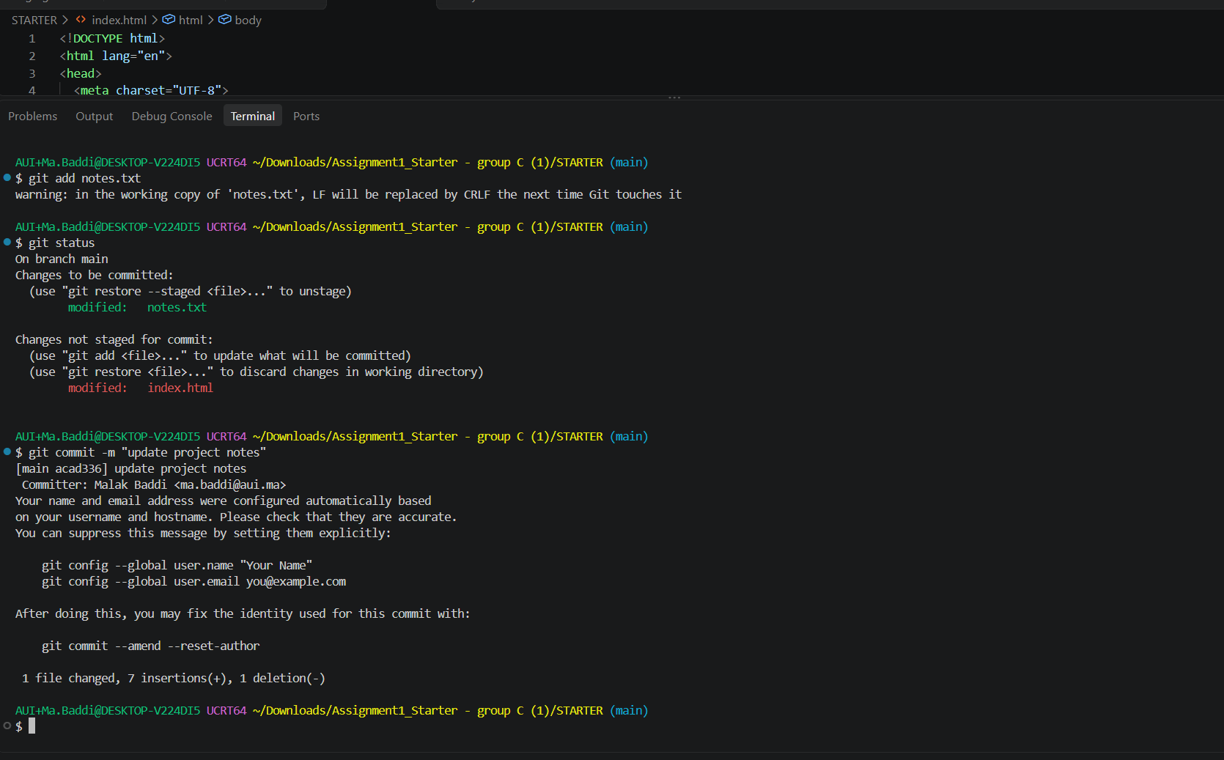4. Branch & Merge
I created a branch named feature/about to develop an About section separately from main. I committed the About feature on that branch, switched back to main, and merged it using git merge feature/about. I used git log --oneline --graph --all to inspect the branch and merge history.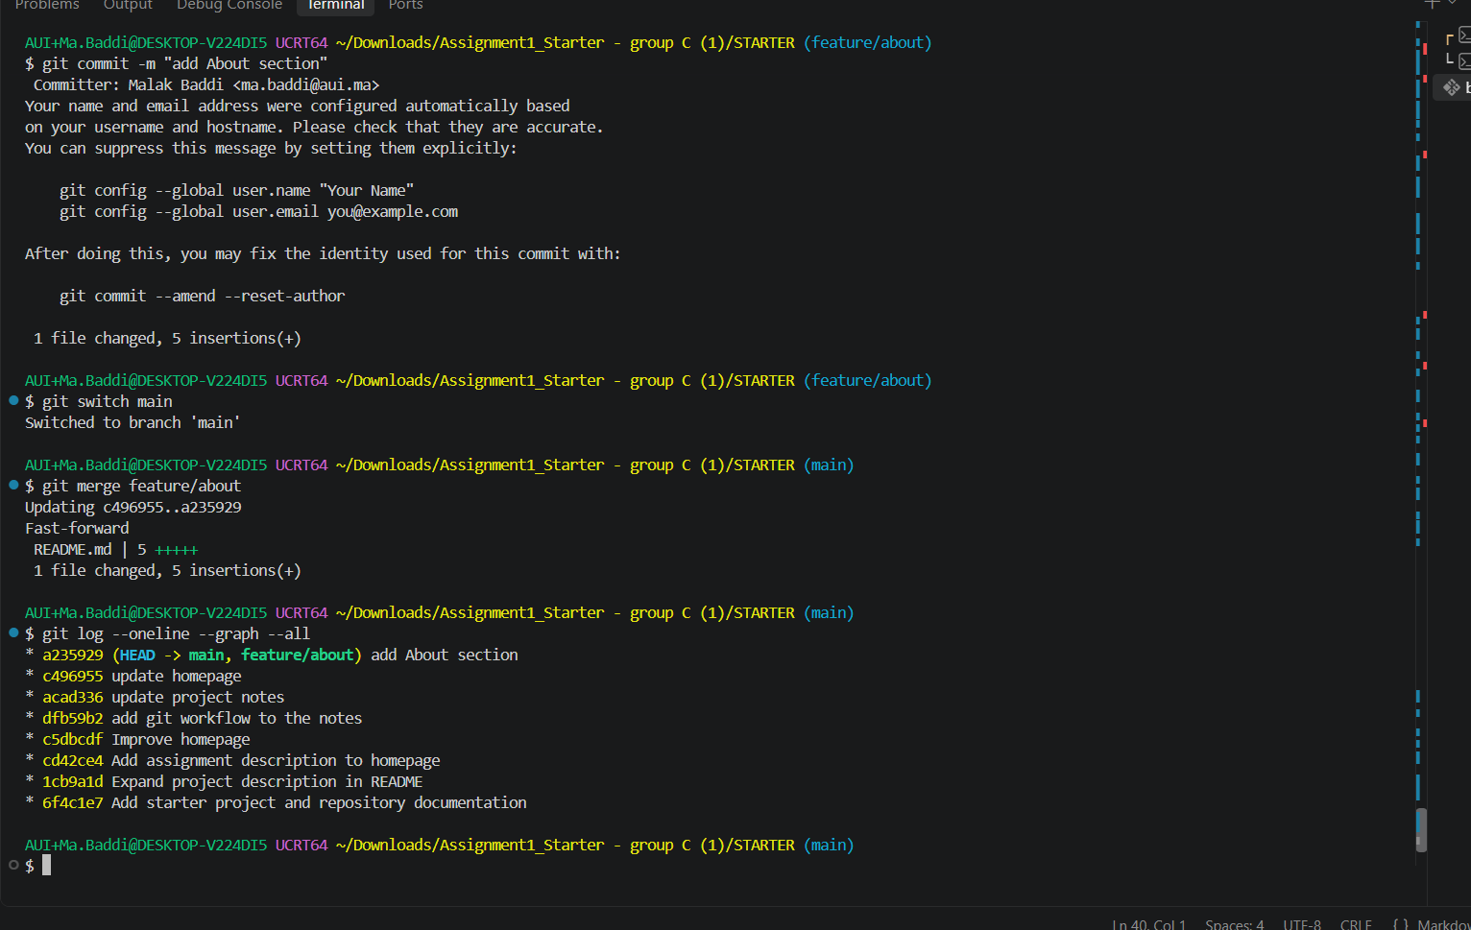

5. Remote Changes
A commit records staged changes in the local repository, while a push uploads local commits to GitHub. Fetch downloads remote updates without integrating them into the current branch, whereas pull fetches and integrates those updates. I edited the README directly on GitHub, fetched the remote changes, and pulled them into my local main branch. I verified the synchronization using git status and inspected file changes and commit history using git diff, git diff --staged, and git log --oneline.

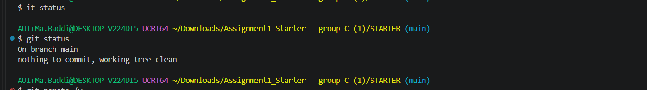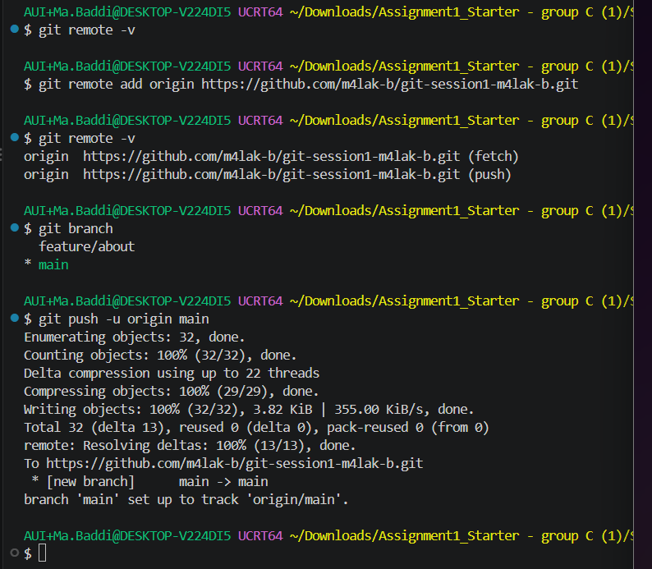

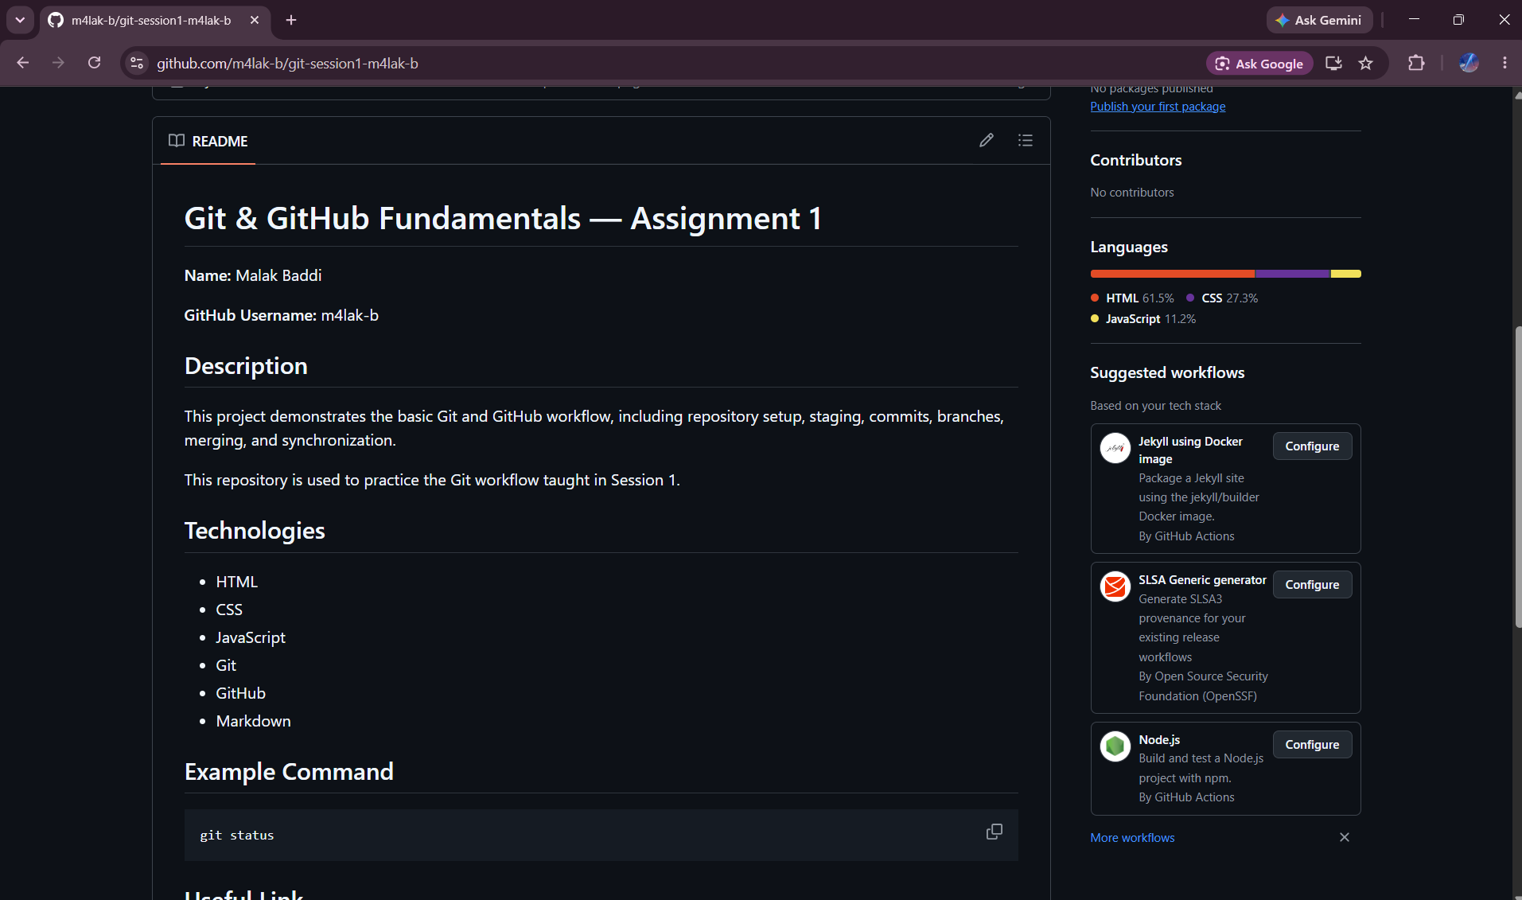
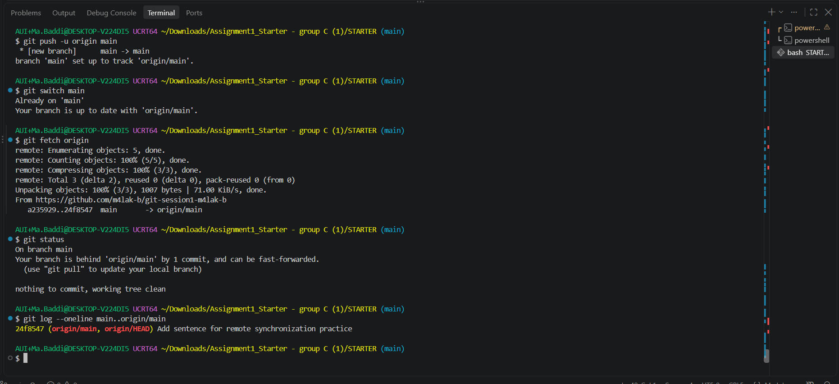
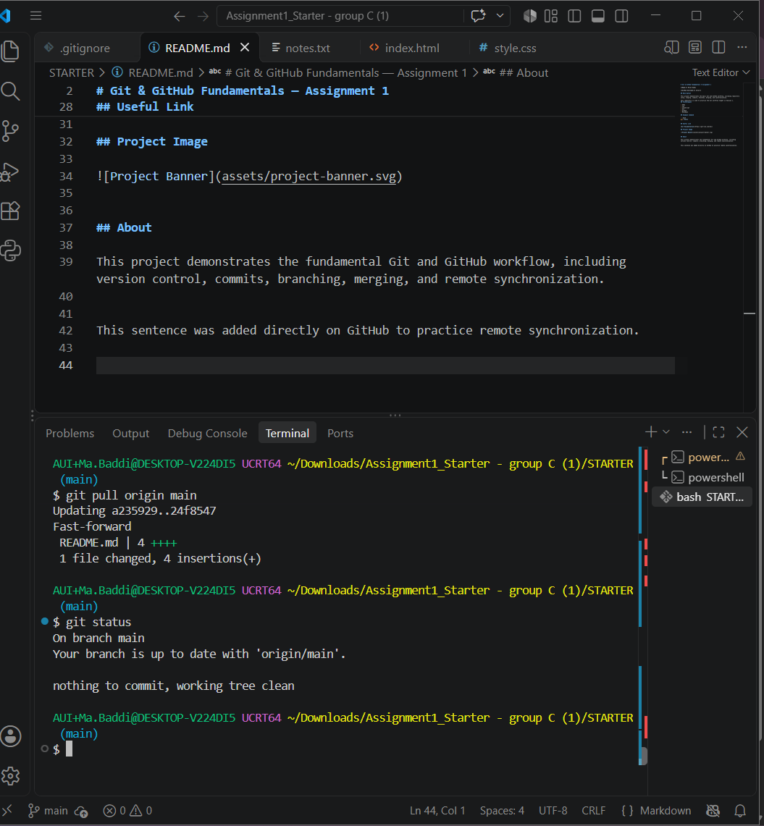

6. Fair Use of AI
I used ChatGPT as a learning tool to understand Git and GitHub commands and organize the steps required for this assignment, because I am not familiar with it. I asked questions about repository initialization, .gitignore, commits, selective staging, branches, merging, and remote synchronization. I followed the instructions in my own terminal and adapted them to the STARTER project you gave us. I verified the results using git status, git log, and the successful push and pull operations

7. Sources & Reflection
Sources
- Session 1 — Git & GitHub Fundamentals, Group C course materials.
- Git documentation: https://git-scm.com/doc
- GitHub documentation: https://docs.github.com/en
- Youtube videos
Reflection
The most challenging concept was understanding the difference between the working directory, staging area, local repository, and remote repository. If Git behaves unexpectedly, I would first use git status to inspect the current branch and identify staged, unstaged, or untracked changes. I would then use git diff and git log to understand the changes and history before deciding what to do next.

